
COMSATS University Islamabad, Attock campus Department of Computer Science
Program: BS-SE
Course: Information System(lab)

Name: Sumbal

Reg No: Sp24-BSE-058

Date: 10, October, 2025

Submitted to: Ma’am Ambreen Gul

Graded Task 1
You have implemented DES there is built in implemented DES in python in
crypto cipher module use it for encryption/decryption and provide output sample
example

from Crypto.Cipher import DES
from Crypto.Random import get_random_bytes
from Crypto.Util.Padding import pad, unpad
# DES key must be exactly 8 bytes long
key = get_random_bytes(8)
def des_encrypt(data, key):
cipher = DES.new(key, DES.MODE_ECB)
padded_data = pad(data, DES.block_size)
encrypted_data = cipher.encrypt(padded_data)
return encrypted_data
def des_decrypt(encrypted_data, key):
cipher = DES.new(key, DES.MODE_ECB)
decrypted_data = unpad(cipher.decrypt(encrypted_data), DES.block_size)
return decrypted_data
# Example usage
if __name__ == "__main__":
# Input data (must be bytes)
data = b"Secret123"
print(f"Original Data: {data}")
# Encrypt the data
encrypted_data = des_encrypt(data, key)
print(f"Encrypted Data: {encrypted_data}")
# Decrypt the data
decrypted_data = des_decrypt(encrypted_data, key)
print(f"Decrypted Data: {decrypted_data}")

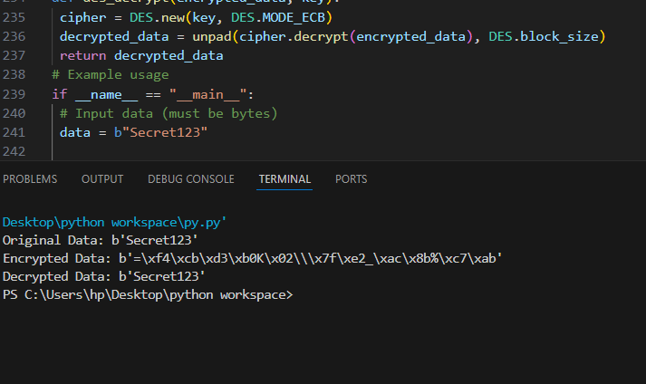
OUTPUT:

Graded Task 2
Visualization of MITM Attack Flow:
from Crypto.Cipher import DES
from Crypto.Util.Padding import pad, unpad
import binascii
import random

# --- helper: make an 8-byte DES key from a small integer (0..255) ---
def make_des_key(x):
assert 0 <= x < 256
# keep 7 bytes fixed, vary only last byte -> tiny keyspace for demo
return b'\x01\x23\x45\x67\x89\xab\xcd' + bytes([x])

# --- DES ECB encrypt/decrypt with padding ---
def des_encrypt(key, data):
cipher = DES.new(key, DES.MODE_ECB)
return cipher.encrypt(pad(data, DES.block_size))

def des_decrypt(key, data):
cipher = DES.new(key, DES.MODE_ECB)
return unpad(cipher.decrypt(data), DES.block_size)

# --- double DES: C = E_{k2}( E_{k1}(P) ) ---
def double_des_encrypt(k1, k2, plaintext):
return des_encrypt(k2, des_encrypt(k1, plaintext))

# --- tiny MITM attack ---
def mitm(plaintext, ciphertext):
keyspace = 256
table = {}

# Phase 1: E_{k1}(P) for all k1
for k1_i in range(keyspace):
k1 = make_des_key(k1_i)
I1 = DES.new(k1, DES.MODE_ECB).encrypt(pad(plaintext, DES.block_size))
table.setdefault(I1, []).append(k1_i) # store possibly multiple k1 indices

# Phase 2: D_{k2}(C) and lookup
candidates = []
for k2_i in range(keyspace):
k2 = make_des_key(k2_i)
I2 = DES.new(k2, DES.MODE_ECB).decrypt(ciphertext)
if I2 in table:
for k1_i in table[I2]:
candidates.append((k1_i, k2_i))

# Verify
verified = []
for k1_i, k2_i in candidates:
k1 = make_des_key(k1_i)
k2 = make_des_key(k2_i)
if double_des_encrypt(k1, k2, plaintext) == ciphertext:
verified.append((k1_i, k2_i))
return verified

# --- demo run ---
if __name__ == "__main__":
P = b"SecretMsg" # plaintext
# choose real secret keys from tiny keyspace
k1_true = random.randint(0, 255)
k2_true = random.randint(0, 255)
K1 = make_des_key(k1_true)
K2 = make_des_key(k2_true)

print("True keys (ints):", k1_true, k2_true)
print("K1 hex :", binascii.hexlify(K1).decode())
print("K2 hex :", binascii.hexlify(K2).decode())

C = double_des_encrypt(K1, K2, P)
print("Ciphertext (hex):", binascii.hexlify(C).decode())

found = mitm(P, C)
if found:
print("Recovered pairs (k1_int, k2_int):")
for a, b in found:
print(f" - {a} , {b} -> k1_hex={binascii.hexlify(make_des_key(a)).decode()} k2_hex={binascii.hexlify(make_des_key(b)).decode()}")
else:
print("No keys recovered (unexpected for this demo).")

OUTPUT:
